Posted 09/04/2012 at 8:47 am by JAV
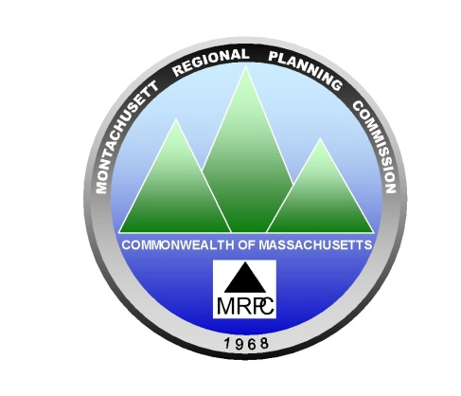
Montachusett Regional Planning Commission (MRPC)
1427R Water Street, Fitchburg, MA 01420
www.mrpc.org
(978)345-7376

MEETING NOTICE

For Steering Committee Members
And Interested Stakeholders

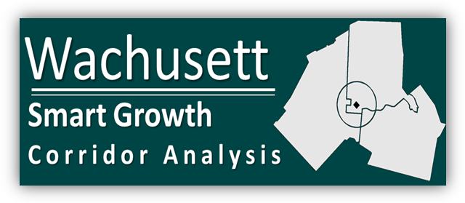
Background: MRPC was awarded $129,500 by the federal Department of Housing and Urban Development’s Community Challenge Grant Program for the development of a Wachusett Smart Growth Corridor Plan. This grant will provide the communities of Fitchburg, Westminster and Leominster with an opportunity to examine and plan for the continued improvement and development of the Wachusett Corridor including the linkage of various means of transportation and planning for future land use, housing, economic development, and open space and recreation opportunities in and around this area.

Date and Time: Tuesday, September 18th, 2012 at 12:00 P.M.

Location: Leominster City Hall, 25 West Street, Room 10, Leominster, MA

Agenda

12:00 PM Light Lunch Provided by MRPC

12:15 PM Welcome: Representative of the City of Leominster

12:20 PM MRPC Staff: Brief Project Status Report, Next Steps, and Today’s Presentation!

12:25 PM Transportation Data and the Wachusett Corridor
Montachusett Regional Planning Commission staff members will present existing transportation data in the relation to the study area i.e. the existing roadway system, average daily traffic, pavement condition, roadway safety, bicycle and pedestrians, etc. Everyone will have an opportunity to provide public comment/input!

C: City and Town Clerks: Please post this notice pursuant to the Open Meeting Law
Please RSVP by September 17th via: Jhume@mrpc.org

